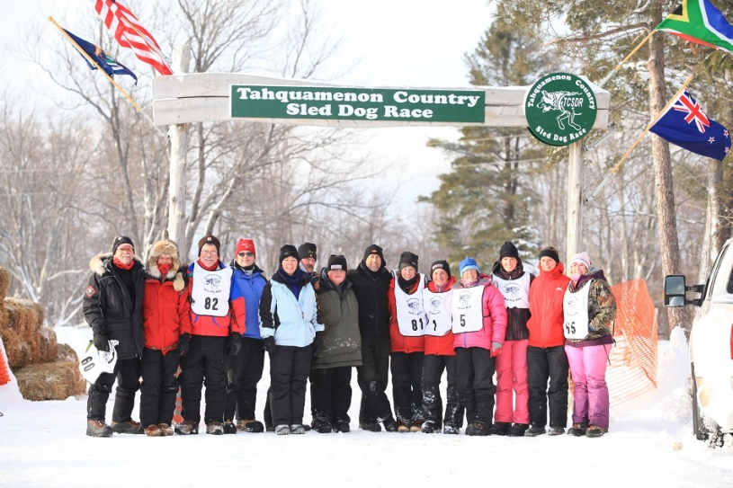
TCSDR RACE WEEKEND PACKAGE!
RACE YOUR OWN 4-DOGTEAM in the Tahquamenon Country Sled Dog Race, January 7, 2017!!
Beginners (those with little or no mushing experience) can race their own team in the 4-dog, 13 mile race.
Novice mushers (those with some mushing experience) can race their own team in the 6-dog, 20 mile race.
The race takes place on Saturday morning at Muskellonge Lake State Park, about 20 miles north of Nature’s Kennel. It is a spectator friendly race and begins and ends at the State Park. The race has many classes, with the 4-dog and 6-dog classes being suitable for beginners or first time racers. You will be racing with other dog teams/kennels and there will be several of our guides racing on the course with you as well. You will be expected to uphold proper race etiquette, understanding that this is a race for FUN!!
Friday, January 6th, arrive at Nature’s Kennel at 10 am to meet your very own race team. You will begin the day by taking your team out (led by an NK guide) to practice passing, stopping, and getting off the sled to fix a tangle, etc. You will get instruction in race etiquette, race day preparations, and what to expect on the big day. Lunch is provided at the kennel. We will finish our day of practice and instruction by 5:30 pm. Dinner is on your own. At 7:30 pm you are required to attend the mandatory musher’s meeting at the American Legion Hall in Newberry. The musher’s meeting is where the race director goes over the race rules, answers questions, and where you will receive your race bib number. Lodging is on your own, there are many hotels in Newberry to choose from.
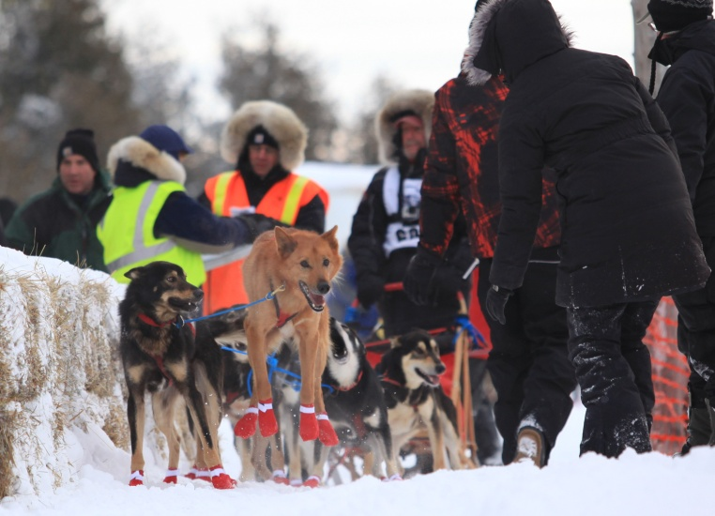
Saturday, January 7th, arrive at Nature’s Kennel at 6:30 am to help load your race team into the dog truck for transportation to Muskellonge Lake State Park, the race start!! The 12-dog pro class begins at 9:30 am, and we want to be sure we are on time to see the big teams head out. The race is spectator friendly, so be sure to bring your fan club along to take photos and cheer loud!! Lunch is on your own, there are vendors at the race site and we will bring along few snacks as it will be a long day. We should be headed back to the kennel around 4 pm. We will have a post-race gathering and all you can eat pasta dinner (provided for mushers, additional cost for handlers/spectators) at 6 pm at the Elks Lodge in Newberry. Lodging is on your own.
Sunday, January 8th, Musher’s Banquet, 9:30 am at the American Legion Hall, Newberry. This is the post-race awards banquet for all mushers. You are not required to attend, but it’s a great wrap up to the weekend. Your package includes one breakfast ticket to this event (additional tickets are available at the door).
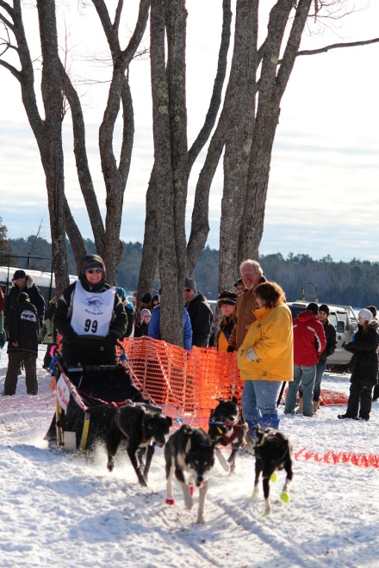
COST: 4-dog class package is $800. 6-dog class package is $950. Cost includes race entry fee, a well trained 4-dog or 6-dog team, dog sled, gangline, and harnesses, full day instruction/training on Friday, lunch on Friday, “race handlers” to help your team out at the race start and provide trail assistance, dog team transportation on Saturday to the race, snacks on Saturday, pizza dinner on Saturday night, race souvenir and awards banquet/breakfast on Sunday. Space is limited.
Race Qualifications: Mushers in the 4-dog class must be 14 years or older and must have driven their own team on a minimum of a half-day trip with Nature’s Kennel or with another outfitter. Mushers in the 6-dog class must be 18 years or older, be in excellent physical condition and must have completed the 4-dog TCSDR race, the Thrilla in McMilla NK race, or have completed an overnight tour with Nature’s Kennel or another outfitter.
Reservation/Race cancellation policy: You must reserve your race team by December 20th 2016. Half of the package cost is due at time of reservation. If the TCSDR is canceled or postponed, your race weekend will still be honored and you will be able to participate in an alternative “race” at Nature’s Kennel on January 9th. You will forfeit the opportunity to participate in the official TCSDR on the postponed date (due to the fact that we will most likely have tours already booked on the alternate date). However, if NK and TCSDR need to cancel, you will receive your deposit back.
FOR MORE INFORMATION: Contact Tasha at Nature’s Kennel, 906-748-0513, info@natureskennel.com

